**CREATE AND CONFIGURE IBM SERVICES**

**IOT WASTON PLATFORM**

|  |  |
| --- | --- |
| Date | 08 November 2022 |
| Team ID | PNT2022TMID19760 |
| Project Name | SmartFarmer – IoT ENABLED SMART FARMING APPLICATION |

**STEP 1:**

Login your IBM Cloud

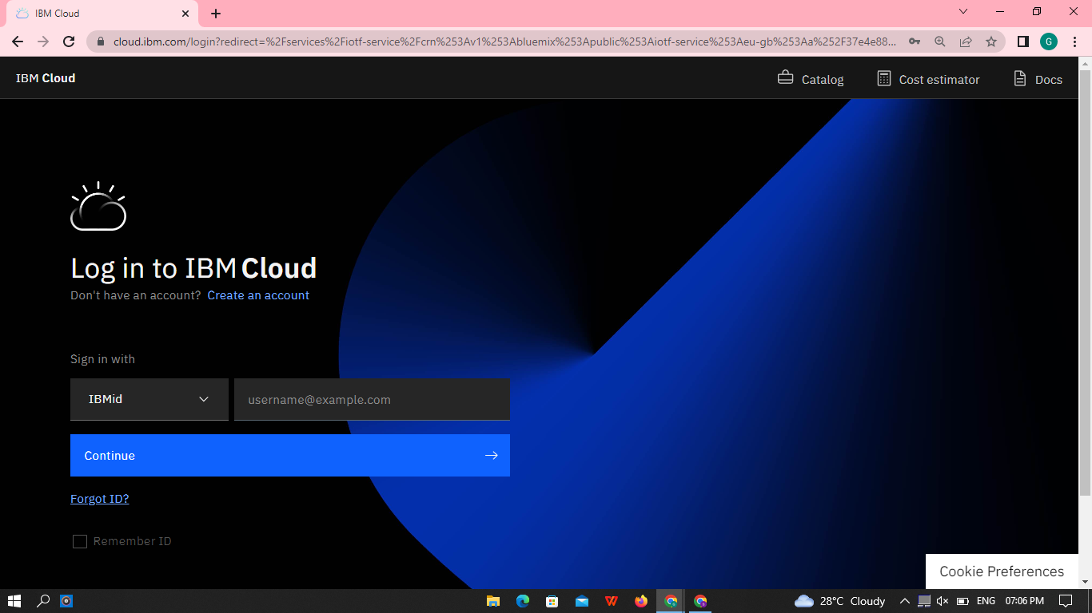

**STEP 2:**

This your Dashboard

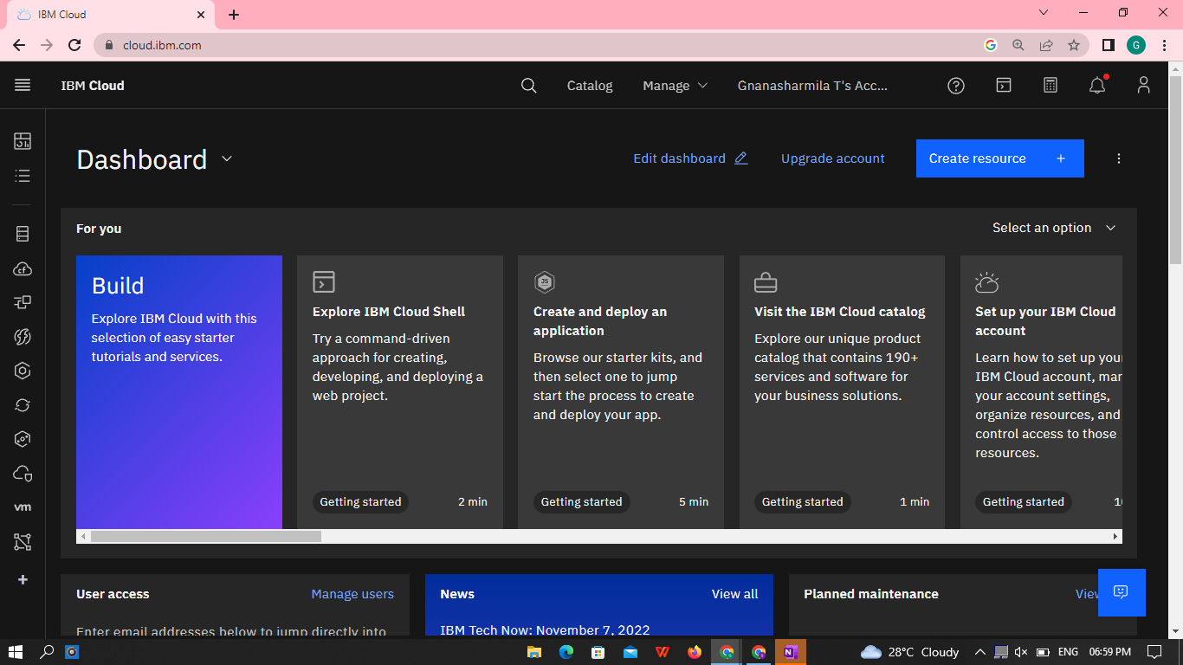

**STEP 3:**

Click Catalog where you find the services and Internet of Thing (IOT) you can select and make Location as London

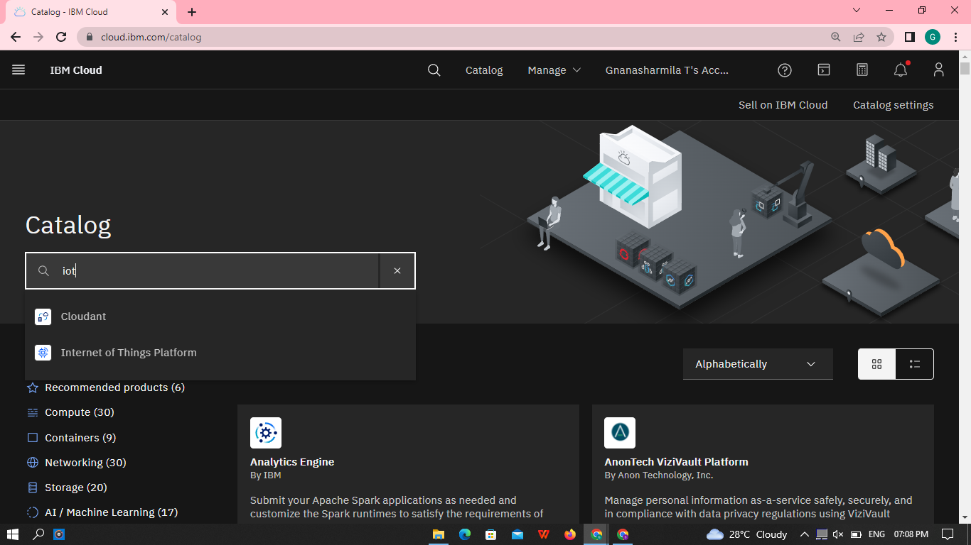

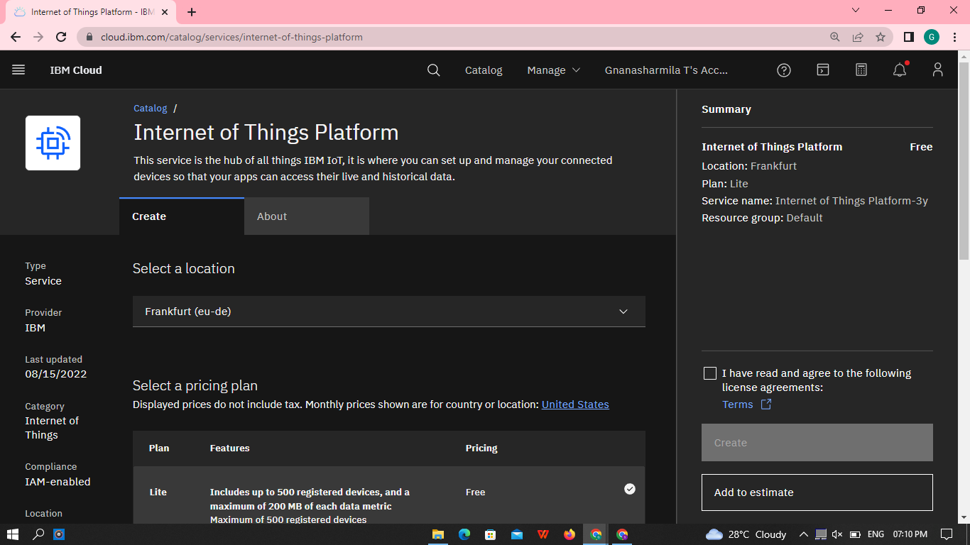

**STEP 4:**

Click to Launch

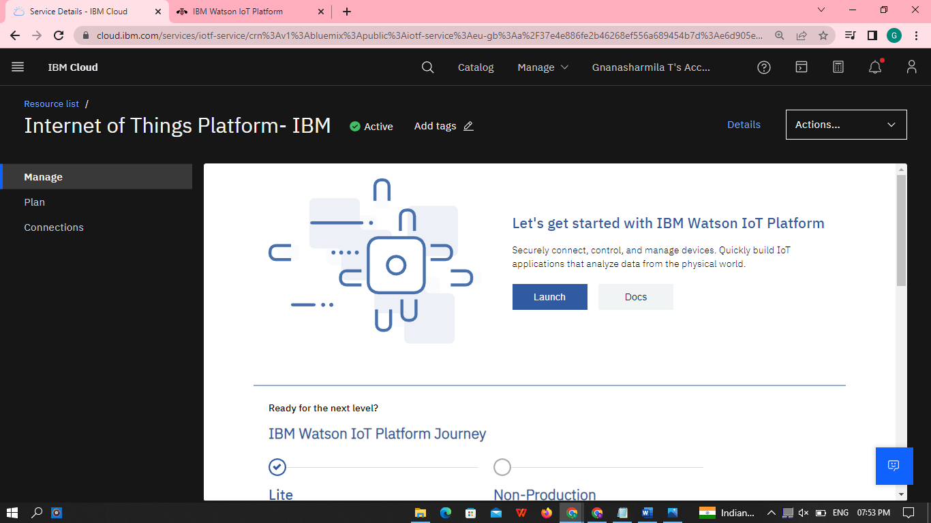

**STEP 5:**

It redirect you to IBM WASTON platform where you need to sign in

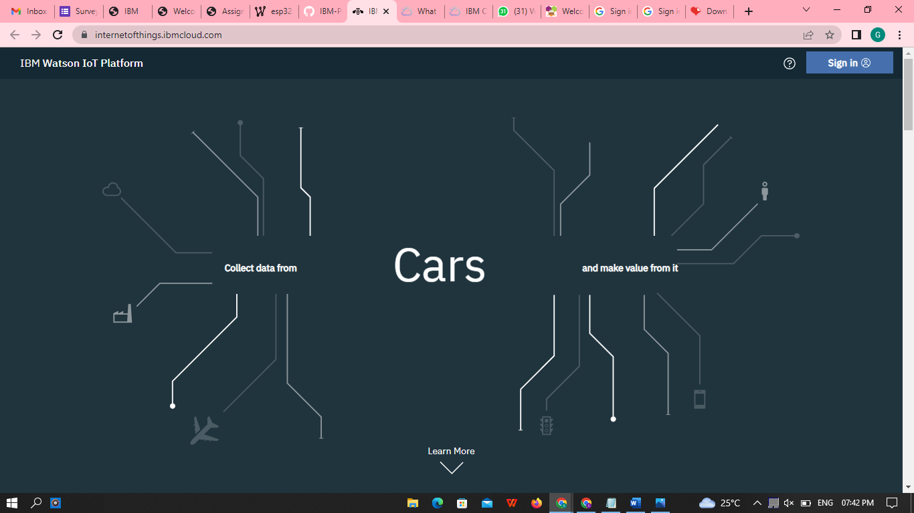

**STEP 6:**

You need to click IBM ID and Select org

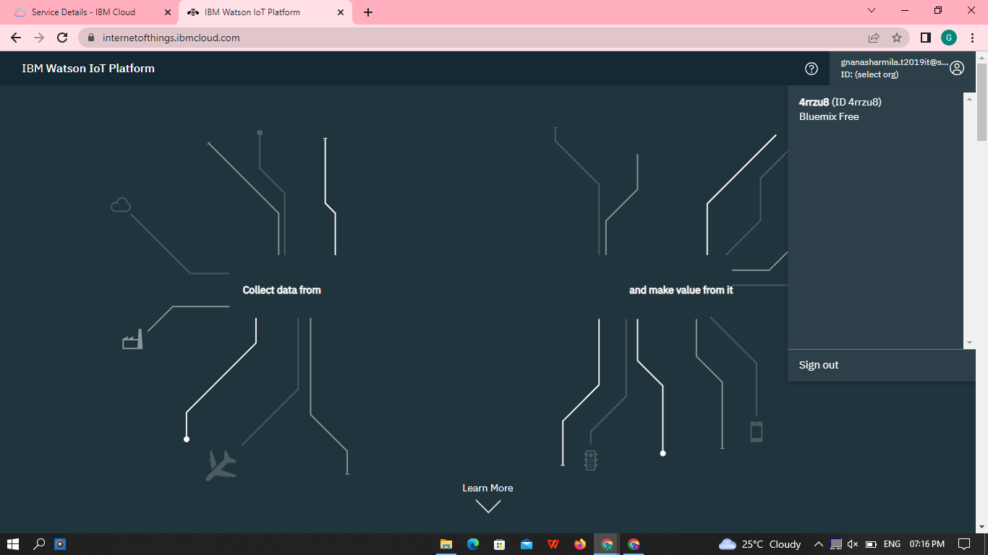

**STEP 7:**

Which is used to add device, app, member, usage, security can be worked,then

click to add device.

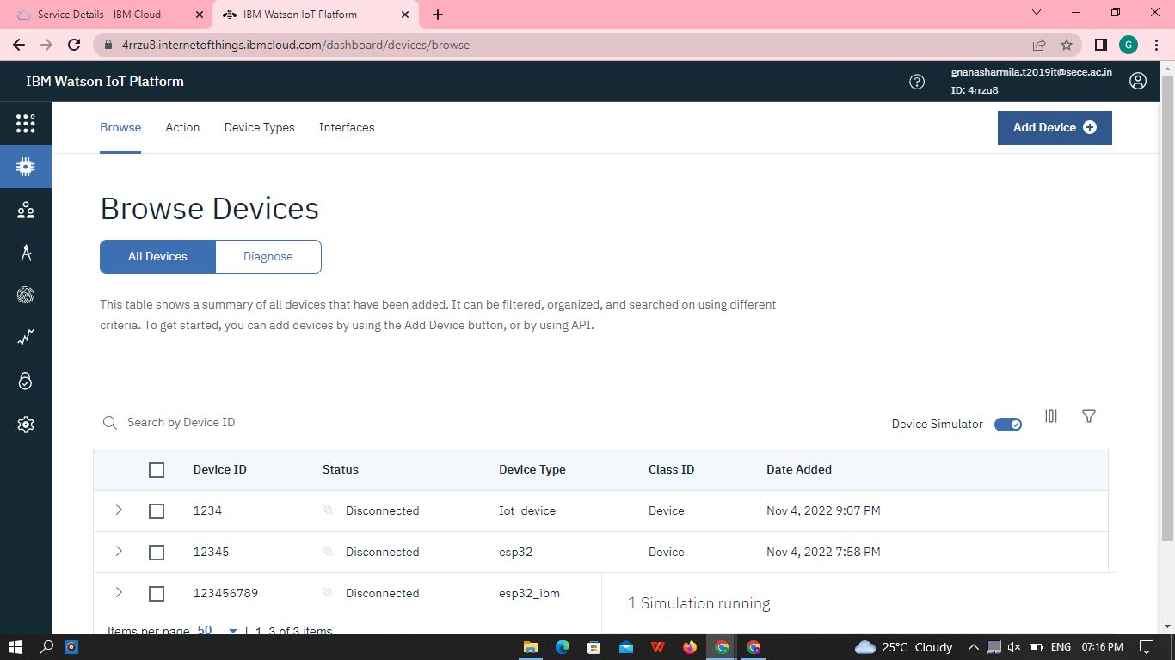

Add Device type and id ,after click next button

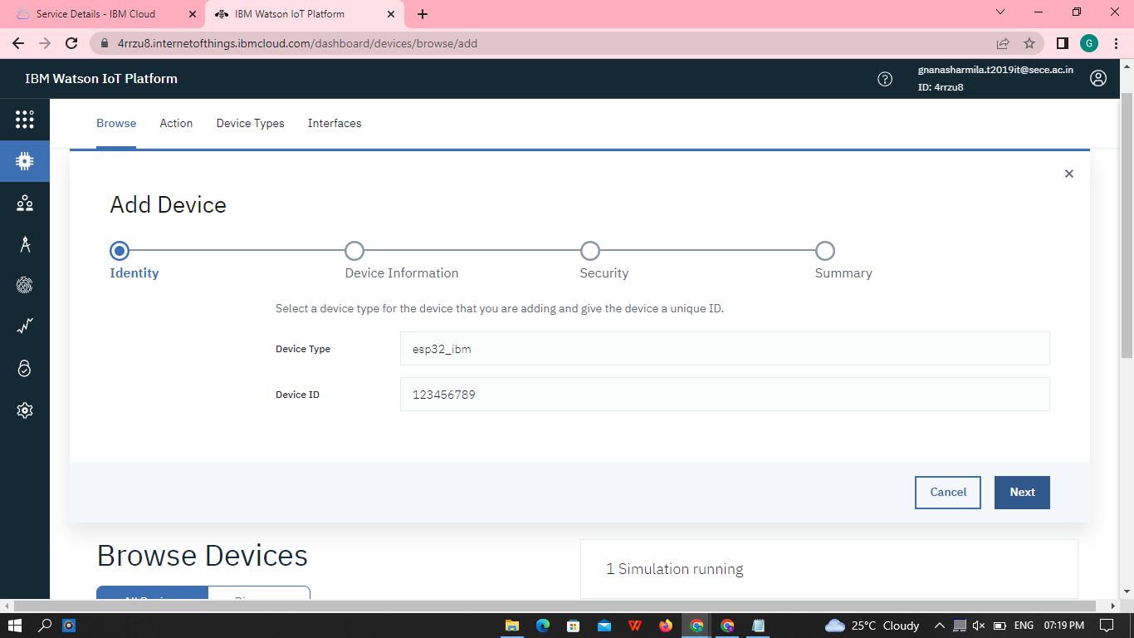

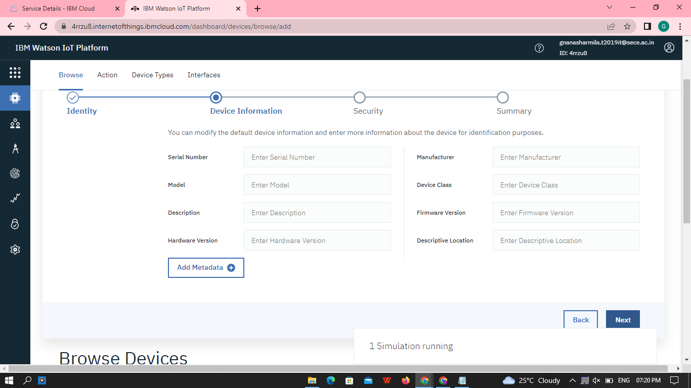

You need to fill the authentication token, then click next button

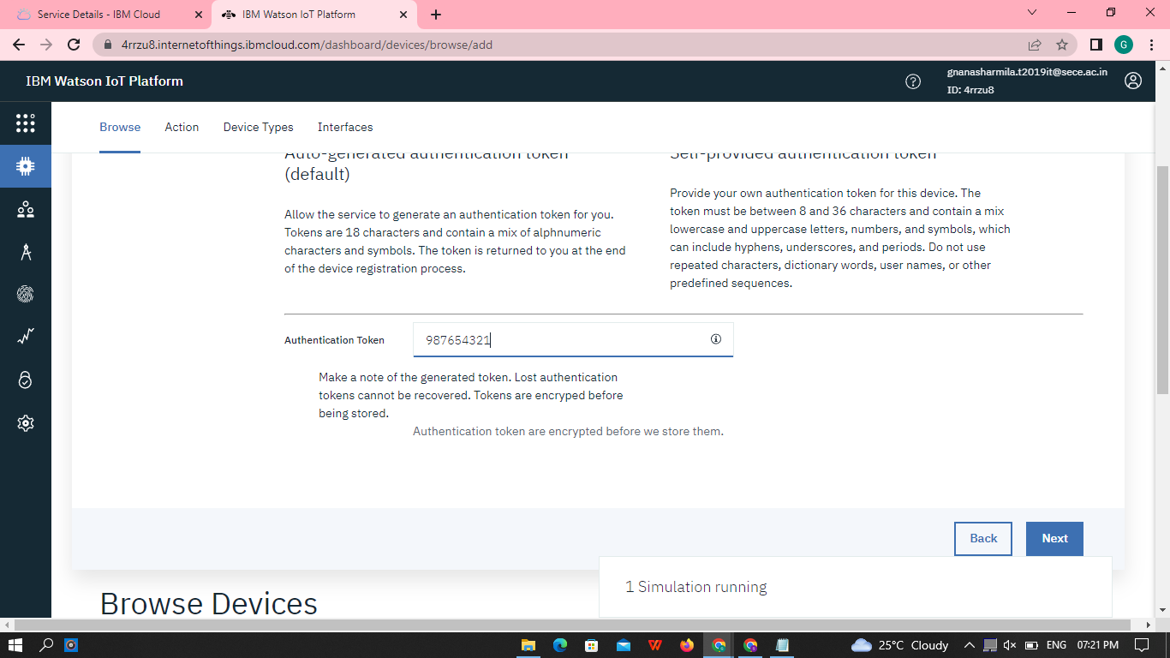

**Click to finish button**

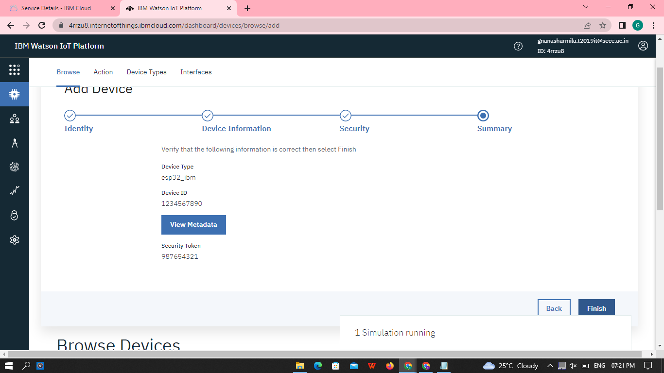

**STEP 8:**

Created a device, the you can note the Organisation ID, Device type, id Authentication method, Authentication token.

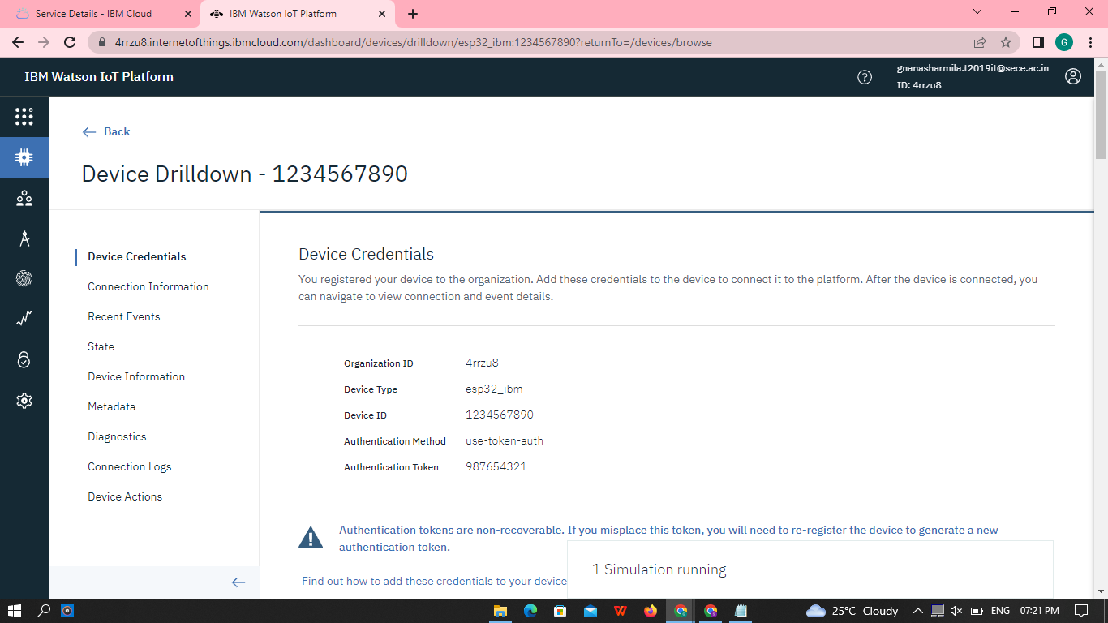

**STEP 9:**

Check boards for risk and security overview card, it uses for graphical representation boards.

